Which structure is the following true for?

For _________, arguments are substituted exactly as entered, without checking for memory, registers, or literals.

|  |  |
| --- | --- |
|  | Procedures |
|  | Both Macros and Procedures |

|  |  |
| --- | --- |
|  | Neither Macros Nor Procedures |
|  | Macros |

Which structure is the following true for?

_________ have a calling mechanism involving the EIP.

|  |  |
| --- | --- |
|  | Macros |
|  | Neither Macros Nor Procedures |

|  |  |
| --- | --- |
|  | Both Macros and Procedures |
|  | Procedures |

Which structure is the following true for?

For _________, the entire code is substituted for each call.

|  |  |
| --- | --- |
|  | Both Macros and Procedures |
|  | Procedures |

|  |  |
| --- | --- |
|  | Macros |
|  | Neither Macros Nor Procedures |

Suppose that a program's data and executable code require 1024 bytes of memory. A new section of code must be added; it will be used with various values 84 times during the execution of a program. When implemented as a macro, the macro code requires 84 bytes of memory. When implemented as a procedure, the procedure code requires 114 bytes (including parameter-passing, etc.), and each procedure call requires 14 bytes.  
  
How many bytes of memory will the entire program require if the new code is added as a macro?



Suppose that a program's data and executable code require 1024 bytes of memory. A new section of code must be added; it will be used with various values 55 times during the execution of a program. When implemented as a macro, the macro code requires 69 bytes of memory. When implemented as a procedure, the procedure code requires 140 bytes (including parameter-passing, etc.), and each procedure call requires 14 bytes.  
  
How many bytes of memory will the entire program require if the new code is added as a procedure?



The code below uses the Space macro which simply displays the number of blank spaces specified by its argument. What is the first number printed to the screen after this code executes? (ignore the .0000 from Canvas)  
  
main PROC  
   push 3  
   push 8  
   call rcrsn  
   exit  
main ENDP  
  
rcrsn PROC  
   push ebp  
   mov ebp,esp  
   mov eax,[ebp + 12]  
   mov ebx,[ebp + 8]  
   cmp eax,ebx  
   jl recurse  
   jmp quit  
recurse:  
   inc eax  
   push eax  
   push ebx  
   call rcrsn  
   mov eax,[ebp + 12]  
   call WriteDec  
   Space 2  
quit:  
   pop ebp  
   ret 8  
rcrsn ENDP



Which of the digital logic symbols from the following diagram is a NOR gate?

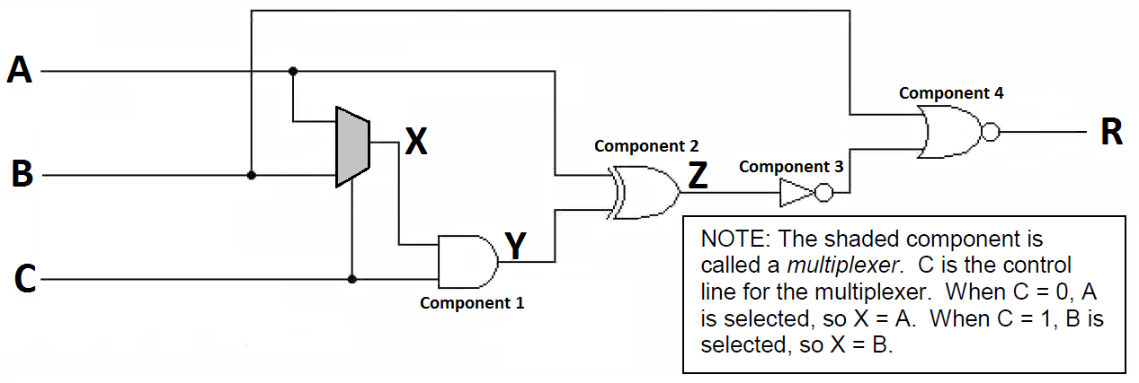

|  |  |
| --- | --- |
|  | Component 1 |
|  | Component 3 |

|  |  |
| --- | --- |
|  | Component 4 |
|  | Component 2 |

Which of the digital logic symbols from the following diagram is a NOT gate?



|  |  |
| --- | --- |
|  | Component 1 |
|  | Component 4 |

|  |  |
| --- | --- |
|  | Component 3 |
|  | Component 2 |

Which structure is the following true for?

_________ are translated only once, and can be called many times.

|  |  |
| --- | --- |
|  | Procedures |
|  | Macros |

|  |  |
| --- | --- |
|  | Both Macros and Procedures |
|  | Neither Macros Nor Procedures |

Which structure is the following true for?

_________ may have parameters.

|  |  |
| --- | --- |
|  | Both Macros and Procedures |
|  | Neither Macros Nor Procedures |

|  |  |
| --- | --- |
|  | Procedures |
|  | Macros |

In the diagram below, which device outputs a "0" if both of its input values are identical?  
i.e. If both inputs are "1" the output is a "0", if both inputs are "0" the output is still a "0".



|  |  |
| --- | --- |
|  | Component 4 |
|  | Component 2 |

|  |  |
| --- | --- |
|  | Component 1 |
|  | Component 3 |

Suppose that a program's data and executable code require 1024 bytes of memory. A new section of code must be added; it will be used with various values 56 times during the execution of a program. When implemented as a macro, the macro code requires 94 bytes of memory. When implemented as a procedure, the procedure code requires 104 bytes (including parameter-passing, etc.), and each procedure call requires 10 bytes.  
  
How many bytes of memory will the entire program require if the new code is added as a macro?



Suppose that a program's data and executable code require 1024 bytes of memory. A new section of code must be added; it will be used with various values 48 times during the execution of a program. When implemented as a macro, the macro code requires 79 bytes of memory. When implemented as a procedure, the procedure code requires 159 bytes (including parameter-passing, etc.), and each procedure call requires 12 bytes.  
  
How many bytes of memory will the entire program require if the new code is added as a procedure?

